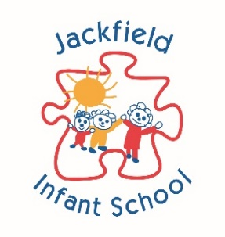
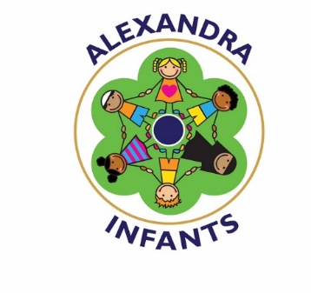
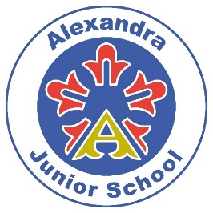

Children with Health Needs Who
Cannot Attend School

POLICY

This policy has been adopted on behalf of all four academies in The New Guild Trust:

Moorpark Junior School
Jackfield Infant School
Alexandra Junior School
Alexandra Infant School

Approval and Review

Committee to Approve Policy | LCGB Finance & Resources Committee
Date of Board / Academy Committee Approval
Chair of Board / Academy Committee
Signature
Accounting Officer
Signature
Policy Review Period | 12 months
Date of Policy Review | October 2019

What Legislation Does This Guidance Refer To?

- Section 19 of the Education Act 1996.
- Equality Act 2010.
- Ensuring a good education for children who cannot attend school because of health needs Statutory Guidance for Local Authorities January 2013.

The Trust:

- Works to ensure that every child should have the best possible start in life through a high quality education, which allows them to achieve their full potential. A child who has health needs should have the same opportunities as their peer group, including a broad and balanced curriculum. As far as possible, children with health needs and who are unable to attend school should receive the same range and quality of education as they would have experienced at their home school.

- Arranges suitable full-time education (or as much education as the child’s health condition allows) for children of compulsory school age who, because of illness, would otherwise not receive suitable education.

- Aims to provide suitable education as soon as it is clear that the child will be away from school for 15 days or more, whether consecutive or cumulative. The Trust liaises with appropriate medical professionals to ensure minimal delay in arranging appropriate provision for the child.

- Ensures that the education children receive is of good quality, as defined in the statutory guidance Alternative Provision (2013), allows them to take appropriate qualifications, prevents them from slipping behind their peers in school and allows them to reintegrate successfully back into school as soon as possible.

- Addresses the needs of individual children in arranging provision. ‘Hard and fast’ rules are inappropriate: they may limit the offer of education to children with a given condition and prevent their access to the right level of educational support which they are well enough to receive. Strict rules that limit the offer of education a child receives may also breach statutory requirements.

For further guidance on providing a good education to pupils in alternative provision, see ‘Alternative Provision: a guide for local authorities, head teachers and governing bodies of schools, pupil referral units and other providers of alternative provision’.

Role and Responsibilities of the Trust

- The Trust is responsible for arranging suitable full-time education for children of compulsory school age who, because of illness, would not receive suitable education without such provision.

- The law does not define full-time education but children with health needs should have provision which is equivalent to the education they would receive in school. If they receive one-to-one tuition, for example, the hours of face-to-face provision could be fewer as the provision is more concentrated.

- Where full-time education would not be in the best interests of a particular child because of reasons relating to their physical or mental health, The Trust aims to provide suitable education on a basis they consider to be in the child's best interests. Full and part-time education will still aim to achieve good academic attainment particularly in English, Maths and Science.

- Some complex and/or long-term health issues may be considered disabilities under equality legislation. This legislation provides that The Trust must not discriminate against disabled children and are under a duty to eliminate discrimination, foster equality of opportunity for disabled children and foster good relations between disabled and non-disabled children.

- The Trust will always endeavour to make reasonable adjustments to alleviate disadvantage faced by disabled children, and where appropriate plan to increase disabled children’s access to Pupil Referral Unit (PRU) premises and their curriculum.

Each Individual School in the Trust:

- Has a named officer responsible for the education of children with additional health needs, and parents should know who that person is.

- Reviews the provision offered regularly to ensure that it continues to be appropriate for the child and that it is providing suitable education.

- Works closely with parents or carers, providers and relevant agencies to constructively ensure the best outcomes for a pupil.

- Ensure that teachers who provide education for children with health needs receive suitable training and support and are kept aware of curriculum developments. They would also be given suitable information relating to a child’s health condition, and the possible effect the condition and/or medication taken has on the child.

- Where they have identified that alternative provision is required, the school would ensure that it is arranged as quickly as possible and that it appropriately meets the needs of the child. In order to better understand the needs of the child, and therefore choose the most appropriate provision, the school will work closely with medical professionals and the child’s family, and consider the medical evidence.

- Will make every effort to minimise the disruption to a child’s education. For example, where specific medical evidence, such as that provided by a medical consultant, is not quickly available, the school will consider liaising with other medical professionals, such as the child’s GP, and consider looking at other evidence to ensure minimal delay in arranging appropriate provision for the child.

- Once parents have provided evidence from a consultant, the school would not unnecessarily demand continuing evidence from the consultant without good reason, even where a child has long-term health problems. Evidence of the continuing additional health issues from the child’s GP should usually be sufficient.

- In cases where the school believes that a consultant’s on-going opinion is absolutely necessary, they should give parents or carers sufficient time to contact the consultant to obtain the evidence.

- Schools will provide appropriate support to children who are absent from school because of illness for a shorter period, for example when experiencing chicken pox or influenza.

- In some cases, where a child is hospitalised, the hospital may provide education for the child within the hospital and the school would not need to arrange any additional education, provided it is satisfied that the child is receiving suitable education.

Working together – with parents, children, health services and schools

- Each individual school in the Trust and/or the provider delivering the education should consult parents before teaching begins. Parents have an important role to play, whether their child is at home or in hospital. Parents and carers can provide useful information that can inform the teaching approach.

- In the case of a looked after child, the LA is responsible for safeguarding the child’s welfare and education. Both the LA and primary carers (foster carers or residential social workers) would fulfil the parental role here and should be engaged. Children should also be involved in decisions from the start, with the ways in which they are engaged reflecting their age and maturity. This will help ensure that the right provision is offered and encourage the child’s commitment to it.

- In all cases, effective collaboration between all relevant services (LAs, CAMHS, NHS, schools and, where relevant, school nurses) is essential to delivering effective education for children with additional health needs.

Reintegration

- When reintegration into school is anticipated, the individual school will plan for consistent provision during and after the period of education outside school. As far as possible, the child should be able to access the curriculum and materials that he or she would have used in school.

- The individual school will ensure that children can successfully remain in touch with their school while they are away. This could be through school newsletters, emails, invitations to school events or internet links to lessons from their school.

- The individual school will set up an individually tailored reintegration plan for each child. This may have to include extra support to help fill any gaps arising from the child’s absence. It may be appropriate to involve the school nurse at this stage as they may be able to offer valuable advice. The school nurse will also want to be aware that the child is returning to school, so that they can be prepared to offer any appropriate support.

- Under equalities legislation schools will consider whether they need to make any reasonable adjustments to provide suitable access for the child.

- Where the absence is likely to be lengthy, the reintegration plan may only take shape nearer to the likely date of return, to avoid putting unsuitable pressure on an ill child in the early stages of their absence. While most children will want to return to their previous school routine at once, some will need gradual reintegration over a longer period.

Public Examinations

- Efficient and effective liaison is important when children with health needs are approaching public examinations. The hospital school, PRU or home tuition teachers should be able to arrange a suitable focus on the child’s education at this stage in order to minimise the impact of the time lost while the child is unable to attend school.

- Awarding bodies will make special arrangements for children with permanent or long term disabilities or learning difficulties, and with temporary disabilities, illness and indispositions, when they are taking public examinations. The individual school will submit applications for special arrangements to awarding bodies as early as possible. Those providing education to a child out of school should provide advice and information to the school to assist it with such applications.

Provision for Siblings

- When treatment of a child’s condition means that his or her family have to move nearer to a hospital, and there is a sibling of compulsory school age, the local authority into whose area the family has moved should seek to ensure that the sibling is offered a place, where provision is available, for example, in a local mainstream school or other appropriate setting.

Further sources of information ‘Alternative Provision: A guide for local authorities, head teachers and governing bodies of schools, pupil referral units and other providers of alternative provision’:

http://www.education.gov.uk/aboutdfe/statutory/g00211923/alternative-provision ‘Advice to schools on attendance’: http://www.education.gov.uk/schools/pupilsupport/behaviour/attendance

