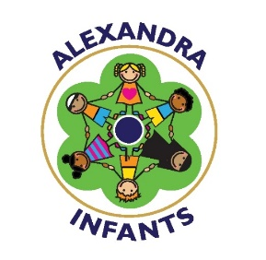

Alexandra Infants – PE Grant (2017-18)
Government money awarded to school | Amount
Grant | £14,788 received  Carry forward 1,276 (from 16/17)  April 2017 - £1300,  Sep 2017-Dec 17 - £3670  Jan 18-July 18 - £8640  Total - £13,610  Spent £13,610  Predicted Carry over18/19: £1178

Area grant allocated | Cost | Impact of spending
- External qualified coaches delivering training to teachers during extended learning time. (Lunchtime Clubs)  - Dance  - Cricket | £300 | Improvement in staff confidence and subject knowledge identified as a CPD need. Offer a wider range of activities to our pupil’s fitness, health and wellbeing.  Language development focus for the children.
- External CPD opportunities for teachers – Courses attended by staff:  - Network launch event for PE coordinators and link governor  - Join oPEN Network Group | £650 | Improvement in staff confidence and depth of subject knowledge.  Improvement in attainment and skills by the pupils.  By accessing the network the subject leader has been able to access a much broader range of PE CPD opportunities and deliver this back to staff in school.  Teachers now have the ability to measure the progress and attainment of our pupils in PE.
- Resources and PE equipment, new Outside Gym (6 pieces of equipment) | £8340 | To enable better quality teaching and improvement in behaviour and activity levels at break times.
- Qualified sports coaching working with all teaching staff during weekly PE sessions and with support staff. | £1300 | Improvement in staff confidence and depth of subject knowledge. Improvement in attainment and skills by the pupils.

