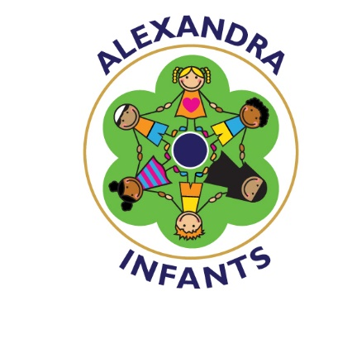

CHARGING AND REMISSIONS POLICY

A statement of the purpose and citation to the legal authority
The purpose of this document is to set out the School’s policy for charging for activities and for the remission of charges, whilst fully complying with the following legislation and regulations:
• Education Act 1996 (sections 449-462)
• Education (School Sessions and Charges and Remissions Policies) Regulations 1999
• The Education (Residential Trips) Regulations 2003;
• The Education (Residential Trips) (Amendment) Regulations 2005;
• The Charges for Music Tuition (England) Regulations 2005
The document has also been reviewed in May 2009 to ensure that provisions within the revised School Admissions Code (in force from 10/02/09) are reflected.
Guiding Principles
Where education is provided wholly or mainly during school hours it is not possible to levy a compulsory charge for any costs including the supply of materials, books, instruments or other equipment.
In addition schools cannot charge for:
• Education provided during school hours (including the supply of any materials, books, instruments or other equipment)
• Education provided outside school hours if it is part of the Curriculum, or part of a syllabus for a prescribed public examination that the pupil is being prepared for at the school, or part of religious education
• Tuition for pupils learning to play musical instruments if the tuition is required as part of the Curriculum, or part of a syllabus for a prescribed public examination that the pupil is being prepared for at the school, or part of religious education
• Entry for a prescribed public examination, if the pupil has been prepared for it at the school
• Examination re-sit(s) if the pupil is being prepared for the re-sit(s) at the school (as stated below however where pupils wish to re-sit modules to improve grades this will be charged)
• An admission application

Schools and local authorities can charge for:
• Any materials, books, instruments, or equipment, where the child’s parent wishes him to own them;
• Optional extras (see below); and
• Music and vocal tuition, in limited circumstances.
Charging (as opposed to requesting a voluntary contribution) for optional and extra-curricular activities
With the provisos that:
(i) Any charge made in respect of individual pupils may not exceed the actual cost of the activity divided equally by the number of pupils participating, and;
(ii) Participation will be on the basis of parental choice and a willingness to meet the charges.
(iii) If the activity cannot be funded without voluntary contributions, the governing body or head teacher will make this clear to parents at the outset. The governing body or head teacher will also make it clear to parents that there is no obligation to make any contribution and that if insufficient voluntary contributions are raised to fund a visit, then it will be cancelled. [If a parent is unwilling or unable to pay, their child will still be given an equal chance to go on the visit.]
Alexandra Infants School may charge for the following activities as permitted under the Education Act and Regulations cited above:
(a) Education provided outside of school time that is not:
• Part of the Curriculum;
• Part of a syllabus for a prescribed public examination that the pupil is being prepared for at the school; or
• Part of religious education.

(b) Individual Music Tuition within School Hours
A charge may be made for individual tuition in playing a musical instrument. The charge is levied according to a scale of charges approved by the Governing Body which allows remissions of charges for pupils whose parents are in receipt of income support. The scale of fees also includes reductions for families with more than one child in receipt of music tuition.
(c) Residential Trips
For residential trips the transport costs will be charged for in addition to board and lodging costs.
(e) Transport
Transport that is not required to take the pupil to school or to other premises where the local authority/governing body have arranged for the pupil to be provided with education.
Voluntary Contributions
The legislation permits schools to ask for voluntary contributions to benefit the school or for any school activities.
Trips & Visits
Alexandra Infants School will ask for voluntary contributions to the cost of day visits that although are not strictly necessary to fulfil the requirement of public examinations or the Curriculum do provide interesting, stimulating and valuable experiences (NB there is an important distinction between voluntary contributions and charges.)
The School will also follow the provisions within the legislation and regulations regarding charging for activities and residential trips that are partly during School hours. If the number of School sessions taken up by the trip is more than 50% of the number of half days spent during the trip it is deemed to have taken place during school hours and as such cannot be charged for. The School will then ask for voluntary contributions. Where there are not enough voluntary contributions to make an activity or trip possible and there is no way to make up the shortfall then it must be cancelled. If the number of school sessions is less than 50% of the number of half days then the trip can be charged for.
Lesson materials
It is hoped that parents will contribute to the cost of providing materials and ingredients for use in practical subjects
The school charges for milk, which is an option for parents to purchase.
The school charges nursery age children for a school meal, again this is an option for parents to purchase.
The school charges nursery age children for provision outside of the 15 funded hours. (£7.50)

Other charges include: personal telephone calls, laminating, photocopying, adult lunches.

Remission of charges
Where the parents/guardians of a pupil are in receipt of appropriate government allowances the Governing Body will remit in full the cost of the board and lodging for any residential activity that it organises for the pupil if the activity is deemed to take place within school hours, or where it forms part of the syllabus for the Curriculum.
In other circumstances, in the cases of family/financial hardship which makes it difficult for pupils to take part in particular activities for which a charge is made, the Governing Body will invite parents/guardians to apply in confidence for the remission of charge in part or in full. Authorisation of remission will be made by the Headteacher.

Reviewed annually.

