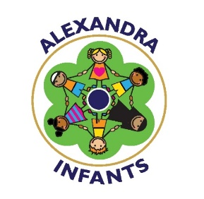

Alexandra Infants – PE Grant (2018-19)
Government money awarded to school | Amount
Grant | Overspend previous year – £297  August 2018 -£7067  Sept 2018-March 2019 -£9993  Total - £17,060  Available to spend 16,763  Autumn Spend - £1273.76  Spring Spend – £1800  Summer Spend- £3463  Total 2018-2019 £6536.76  Amount left -£10,226.24

Area grant allocated | Cost | Impact of spending
- External qualified coaches delivering training to teachers during extended learning time. (Lunchtime Clubs)  (Gymnastics) | £1440 Spring ASM Coach)  £360 ASM  (After school) | Improvement in staff confidence and subject knowledge identified as a CPD need. Offer a wider range of activities to our pupil’s fitness, health and wellbeing.  Language development focus for the children.
- Resources and PE equipment | £308 | To enable better quality teaching and improvement in behaviour and activity levels at break times.
- External qualified coaches delivering training to teachers during extended learning time. (Lunchtime Clubs) Athletics | £1430  £300 (after school) | Improvement in staff confidence and subject knowledge identified as a CPD need. Offer a wider range of activities to our pupil’s fitness, health and wellbeing.  Language development focus for the children.
- Swimming Year 2- 5 weeks of intensive swimming lessons. | £900 | Children become more confident in water. Children to be offer a wider range of activities to our pupil’s fitness, health and wellbeing.
- External coaches delivery a variety of new sports during Sports Week | £425 | Improvement in staff confidence and subject knowledge identified as a CPD need. Offer a wider range of activities to our pupil’s fitness, health and wellbeing.  Language development focus for the children.
- Sports Day Resources – medals/stickers | £53.68 | Extrinsic rewards for the child when participating in sporting activities.

